

fnukad 30-11-2023

**jaxksyh ,oa esgUnh izfr;ksfxrk dk vk;kstu**

“kkldh; jkuh lw;Zeq[kh nsoh egkfo|ky; Nqfj;k esa laLFkk fljkse.kh izkpk;Z MkW- lq’kek pkSjs ¼usrke½ ds ekxZn”kZu esa LohiuksMy vf/kdkjh lqJh izhfrckyk Bkdqj ¼lgk;d izk/;kid½ ds usr`Ro esa fnukad 30-11-2023 dks^ ^**SVEEP xfrfof/k ds varxZr^ ^jaxksyh ,oa esgUnh izfr;ksfxrk** dk vk;kstu fd;k x;kA ernkrk tkx#drk ds ifjis{; esa Nk=&Nk=kvksa us viuh lgHkkfxrk nhA jaxksyh izfr;ksfxrk esa izFke LFkku nqxkZ ,oa oanuk] (B.SC. – II) f}rh; LFkku MkWyh flUgk (B.SC. – II) o r`rh; LFkku nsokf”k’k] (B.SC. – II) izkIr fd;kA esgUnh izfr;ksfxrk esa izFke LFkku vatyh nsokaxu] (B.A. – II) f}rh; LFkku lq’kek dlsj] (B.SC. – II) o r`rh; LFkku T;ksrh eaMkoh] (B.SC. – II) izkIr fd;kA

laiw.kZ dk;Zdze dk lQy vk;kstu LohiuksMy vf/kdkjh lqJh izhfrckyk Bkdqj ¼izk.kh”kkL=½ }kjk fd;k x;kA bl vk;kstu esa ofj’B izk/;kid MkW- jktsUnz “kekZ] MkW- ,p-,l- HkfV;k] lgk;d izk/;kid Jh ujsUnz dqekj mefj;k] lqJh nhfidk /kzqos] Jh fou; pkSjs ,oa leLr vfrfFk O;k[;krk Jh pSrjke ;kno] Jh xUUkw lkgw] lqJh bafnjk banq] Jh xSanyky lksudj] lqJh egs”ojh lkgw ,oa lHkh Nk=&Nk=k,a mifLFkr jgsA

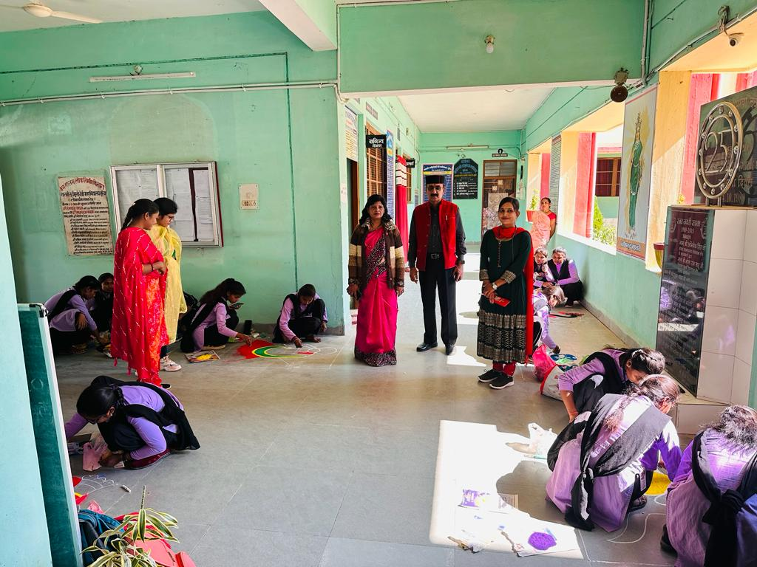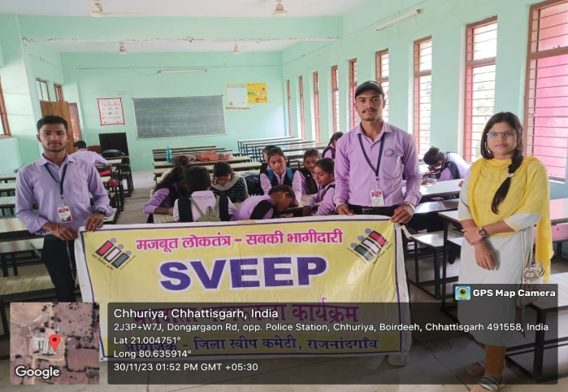

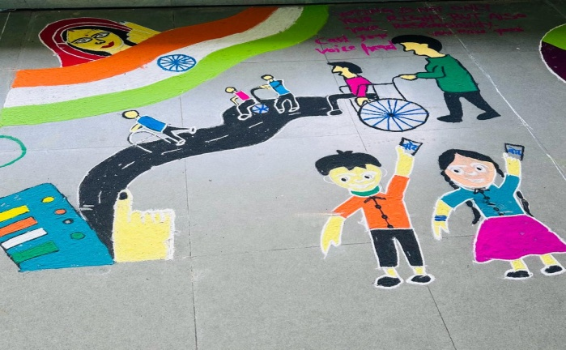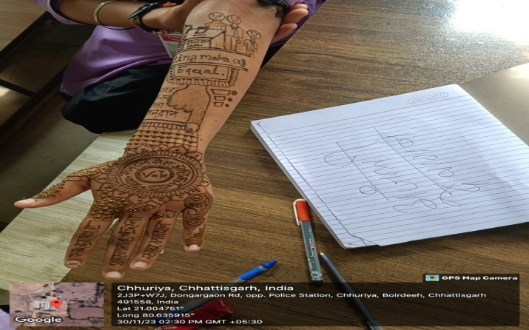

MkW- lq’kekpkSjs ¼usrke½

izkpk;Z